REAL BRIDGE FRIDAY NIGHTS

Bridge Club Aberdeen are hosting 5 evening sessions on Real Bridge up until the end of March. Each session begins at 7.00pm. A warm welcome is extended to members who play in the areas of North District, and you do not need to be an SBU member to join these very sociable events where you can see one another and talk to one another. Do tell your friends.
The dates are as follows:
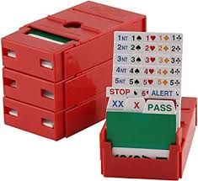
FRIDAY 28TH JANUARY
FRIDAY 11TH FEBRUARY
FRIDAY 4TH MARCH
FRIDAY 11TH MARCH
FRIDAY 25TH MARCH
The cost per session is £1.00. £5.00 for 5 tournaments. Juniors are free.
Contact treasurer@aberdeenbridgeclub.co.uk for instructions on how to pay.
You don’t need a partner as we can pair you up with someone but do get in touch with the convener if you are coming on your own so we can have spare players at the ready.
lorainefindlay@hotmail.co.uk
To find out more about Real Bridge click on the following link.
https://realbridge.online/
The links for each week’s tournament will be posted on the North District and Aberdeen Bridge Club websites.
This week’s link is for Friday 28th at 7pm. Just click on the link and sit at a table with your partner.
https://play.realbridge.online/df.html?p=220128127872&q=FridayNight1p
DOORS OPEN AT 6.45 PM. DON’T CLICK ON THE LINK UNTIL THEN. PLEASE TRY TO BE SEATED BY 6.55 PM.

